RHM Overview

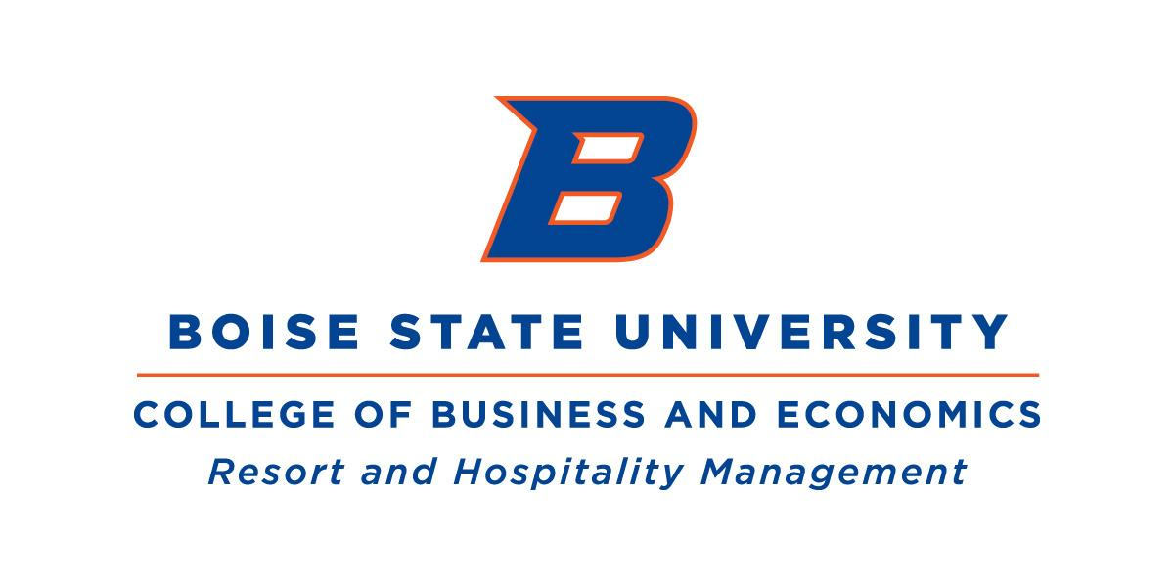
Resort and Hospitality Management
Boise State University
College of Business and Economics

For additional information, contact:
Ashley Walter (ashleywalter@boisestate.edu) or Kent Neupert (kneupert@boisestate.edu)

Key Program Information: Career Fairs, Organizational Trainings & Internships

1. Career Fair Participation: Dates, Cost, and Process
Below is an overview of the opportunities available through BSU to engage with our students. Many of the university-level events take place each semester, while COBE-level events focus specifically on students within the College of Business and Economics.
BSU CAREER FAIR OVERVIEW:
Dates | Fair Name | Primary Focus | Standard Fee | Process / Link
Occurs day before the BSU Fall Career Fair | COBE Pre-Career Fair Mixer | Focused networking event and mixer hosted by the College of Business and Economics - Career Services, excellent for targeted branding and pre-recruitment networking before a major fair. | ~$250 | First come, first serve basis (max 30 employers)
Fall: Mid-October  Spring: Mid-February | University-Wide Career Fair | General full-time, part-time, and internship recruitment. Includes COBE students. | ~$550 (Includes table and lunch for 3 reps) | Career Fair Event Page
Spring: Date TBD | Hospitality Career Fair | Engage and interact with COBE and RHM students in a personalized career fair Recruitment for full-time, part-time and internship opportunities. | Free | If interested, contact: AshleyWalter@boisestate.edu
Fall: Late August  Spring: Mid-April | Part-Time & Summer Job Fair | High-volume hiring for summer, part-time, and seasonal roles. | ~$85 (Standard Booth) | Career Fair Event Page

2. Non-Credit RHM Modules: Overview and Examples
Our non-credit RHM modules are being designed as flexible, high-impact micro-credentials for industry partners, enabling efficient employee upskilling and professional development.
We offer two distinct delivery models to target different employee levels and organizational needs.
- Online, Self-Paced Modules (Front-Line Employee Training)
These modules focus on scalable, standardized training and ensuring a consistent foundational skill set across the industry.
  - Target Audience: front-line employees, apprentices, seasonal employees, etc
  - Length of Training: Individual training modules are designed to be completed in under 60 min. Employees can pause and pick up as their time allows
  - Training Topics:
    - Guest Services / Customer Service Basics: Distinguishing the difference between service and hospitality
    - Workplace Professionalism: Essential soft skills, communication, and team dynamics
  - Cost:
    - Free Option (WDC Partnership Model): Organizations must be willing to report SSN through their IDOL portal of employees who use the training **This offer is only available until March 15, 2026, all training must be completed by this date.**
    - Cost per Seat (Standard Industry Model): Organizations unwilling or unable to report SSNs can purchase seats at $25/seat/Training topic

- In-person, Interactive Group Training Modules (Leadership & Management Development)
This model delivers high-value, facilitated group training led by BSU RHM faculty or industry experts. It is specifically designed to develop supervisory and management skills.
  - Target Audience: Supervisors, Managers and High-Potential Leaders
  - Delivery Model: In-person facilitated training, with a minimum length of 60min (can be longer, depending on the training and organizational needs)
  - Training Topics:
    - Conflict to Coaching: Leading through Difficult Conversations: Structured communication modules for handling sensitive, performance based, or behavioral issues.
    - The Coaching Manager: Coaching Strategies for Employee Growth: Focuses on the manager's role as a mentor and guide to maximize employee potential. Supporting managers help employees grow and develop new skills and build leadership capacity.
    - Other: Open to developing other in-demand trainings
  - Cost:
    - Free Bundled Option (WDC Partnership Model): Organizations that are using the online, self-paced modules can add on ONE in-person group training, free of charge, with the requirement that they are willing to report SSN through their DOL portal of employees who attend the training. **This bundle offer is only valid until March 15, 2026; all training must be complete by this date.**
    - Cost per Training (Standard Industry Model): Organizations unwilling or unable to report SSNs, can purchase individual trainings at $1,500 per in-person training for up to 25 people.

3. RHM Internship Requirements: The Student-Led Leadership Project (RHM493)
The RHM 493 course functions as the academic capstone for completion of the student's certificate within a paid employment setting. This is not a traditional internship. We encourage students to secure a part-time or full-time position at an organization first. Once they are embedded in their paid role, the student enrolls in RHM 493, which requires them to execute a Student-Led Leadership Project within their job function.
RHM Leadership Project Value:
- Securing Talent Pipeline: This model is designed to convert students into committed, long-term employees. We strongly encourage students to secure part-time or full-time employment (not just a traditional internship) at the host organization. By completing the Leadership Project within a paid role, they demonstrate commitment and business acumen, providing organizations with a high-quality, pre-vetted employee for the industry workforce.
- Displaying Proactive Leadership: Students are trained to identify a gap or opportunity and take full initiative to plan, implement, and solve a small problem, regardless of their job title. This proves that leadership is not tied to a position and encourages valuable initiative from day one.
- Receiving Measurable Project Outcomes: The course requires students to outline project goals and outcomes that must align with the organization's needs. The host organization receives a completed project that "gives back to the organization" with clear, quantifiable metrics.
- Mentoring Future Leaders: Organizations contribute to the development of a highly-trained, results-oriented professional, ideally leading to employee growth and value for the organization.

Key Partnership Requirements:
We are open to various employment structures. The following requirements ensure the placement meets both academic standards and facilitates a successful experience for the student:
- Paid Employment Required: All RHM 493 placements must be paid employment, hence why we encourage students to seek part-time/full-time roles. Compensation ensures the student can afford to live and work in the designated area (if outside Treasure Valley) and views the role as a secure, professional position.
- Structured Placement: If an organization is offering a ‘traditional (paid) internship’, we will accept this as well, as long as the internship is clearly outlined and structured. The student's primary employment contract is separate from the RHM 493 academic course, but the course requires them to execute a project within that paid role.
- Housing Provision: For employees/students who are completing a traditional, seasonal internship and who are not local, housing will need to be provided or subsidized by the host organization to make the position feasible.
- Supervisory Sign-Off Required: The student's direct supervisor must sign off on the Leadership Project to confirm it met the organization's needs.

Training Overview
Conflict to Coaching: Leading through Difficult Conversations Training
Est Training Time (~2 hours including breaks)

Overview: This high-impact training focuses on transforming workplace conflict into opportunities for growth and problem-solving.

Key Workshop Takeaways:
- Understanding Conflict: Learn that conflict is a natural result of people's inherent differences and is not always negative. The goal is to focus on how you deal with it as a leader
- The Resolution Process: Gain a solid understanding of the six phases of conflict resolution, including how to create an effective atmosphere, create a mutual understanding, and get to the root cause.
- 5 Conflict Styles: Master the five widely accepted conflict resolution styles: Collaborating, Competing, Compromising, Accommodating, and Avoiding; and know when to strategically use each one for optimal outcomes.
- Creating a Positive Atmosphere: Develop leadership skills in establishing a powerful problem-solving force by neutralizing emotions, setting ground rules, and choosing the appropriate time and place for difficult conversations.
Our objective is to support leaders to understand and adopt the right attitude, to turn "the courageous conversation you don't want to have" into a productive interaction that deepens working relationships and employee growth and engagement.

Non-Credit Overview


Resort and Hospitality Management
Boise State University
College of Business and Economics

For additional information, contact:
Ashley Walter (ashleywalter@boisestate.edu) or Kent Neupert (kneupert@boisestate.edu)

Non-Credit RHM Modules: Overview and Examples
Our non-credit RHM modules are being designed as flexible, high-impact trainings for industry partners, enabling efficient employee upskilling and professional development.
We offer two distinct delivery models to target different employee levels and organizational needs.
- Online, Self-Paced Modules (Front-Line Employee Training)
These modules focus on scalable, standardized training and ensuring a consistent foundational skill set across the industry.
  - Target Audience: front-line employees, apprentices, seasonal employees, etc
  - Length of Training: Individual training modules are designed to be completed in under 60 min. Employees can pause and pick up as their time allows
  - Training Topics:
    - Guest Services / Customer Service Basics: Distinguishing the difference between service and hospitality
    - Workplace Professionalism: Essential soft skills, communication, and team dynamics
  - Cost:
    - Free Option (WDC Partnership Model): Organizations must be willing to report SSN through their IDOL portal of employees who use the training **This offer is only available until March 15, 2026, all training must be completed by this date.**
    - Cost per Seat (Standard Industry Model): Organizations unwilling or unable to report SSNs can purchase seats at $25/seat/Training topic

- In-person, Interactive Group Training Modules (Leadership & Management Development)
This model delivers high-value, facilitated group training led by BSU RHM faculty or industry experts. It is specifically designed to develop supervisory and management skills.
  - Target Audience: Supervisors, Managers and High-Potential Leaders
  - Delivery Model: In-person facilitated training, with a minimum length of 60min (can be longer, depending on the training and organizational needs)
  - Training Topics:
    - Conflict to Coaching: Leading through Difficult Conversations: Structured communication modules for handling sensitive, performance based, or behavioral issues.
    - The Coaching Manager: Coaching Strategies for Employee Growth: Focuses on the manager's role as a mentor and guide to maximize employee potential. Supporting managers help employees grow and develop new skills and build leadership capacity.
    - Other: Open to developing other in-demand trainings
  - Cost:
    - Free Bundled Option (WDC Partnership Model): Organizations that are using the online, self-paced modules can add on ONE in-person group training, free of charge, with the requirement that they are willing to report SSN through their DOL portal of employees who attend the training. **This bundle offer is only valid until March 15, 2026; all training must be complete by this date.**
    - Cost per Training (Standard Industry Model): Organizations unwilling or unable to report SSNs, can purchase individual trainings at $1,500 per in-person training for up to 25 people.

